# Learning Outcome

After completing this module, the student should be able to understand basic of HTML

1. Create a data spreadsheet (2 Hrs)
2. Optimize HTML table rendering (1 Hr)
3. Create collapsible content with HTML (1 Hr)
4. Add context menus to a webpage (2 Hr)
5. Create dialog boxes with HTML (2 Hrs)
6. Add multiple languages into a single webpage (2 Hrs)
7. Controlling of HTML line breaking (1 Hrs)
8. Mark changes (added and removed text) (2 Hrs)
9. Add responsive image to a webpage (3 Hrs)
10. Add vector image to a webpage (3 Hrs)
11. Add a hit map on top of an image (2 Hrs)
12. Animation (1 hr)
13. Transform (1 hr)

# Activity 14

## Aim: Create a data spreadsheet(2 hr)

**Learning outcome:** Able to Structuring the web.

**Duration:** 2 hour

**List of Hardware/Software requirements:**

1. Windows/Ubuntu OS
2. Text Editor- Sublime Text, Notepad++
3. Browser

**Code/Program/Procedure (with comments):**

<!DOCTYPE html>

<html>

<script type="text/javascript"> function createCSV() {

csvRows = [["label first","details of label 1"],["label sec","details of label 2"],["label 3","details of label 3"],["label 4","details of label 4 and 3"],["label 5","details of label 5"],["label 6","details of label 6"],["label 7","details of label 7"],["label 8","details of label 8"],["label 9","details of label 9"]];

var csvString = csvRows.join("%0A");

var a = document.createElement('a');

a.href = 'data:attachment/csv,' + csvString;

a.target = '_blank';

a.download = 'myFile.csv';

document.body.appendChild(a);

a.click();

}

</script>

<body>

<form action="" method="post">

<input type="button" value="Create" >

</form>

</body>

</html>

**Output/Results snippet:**

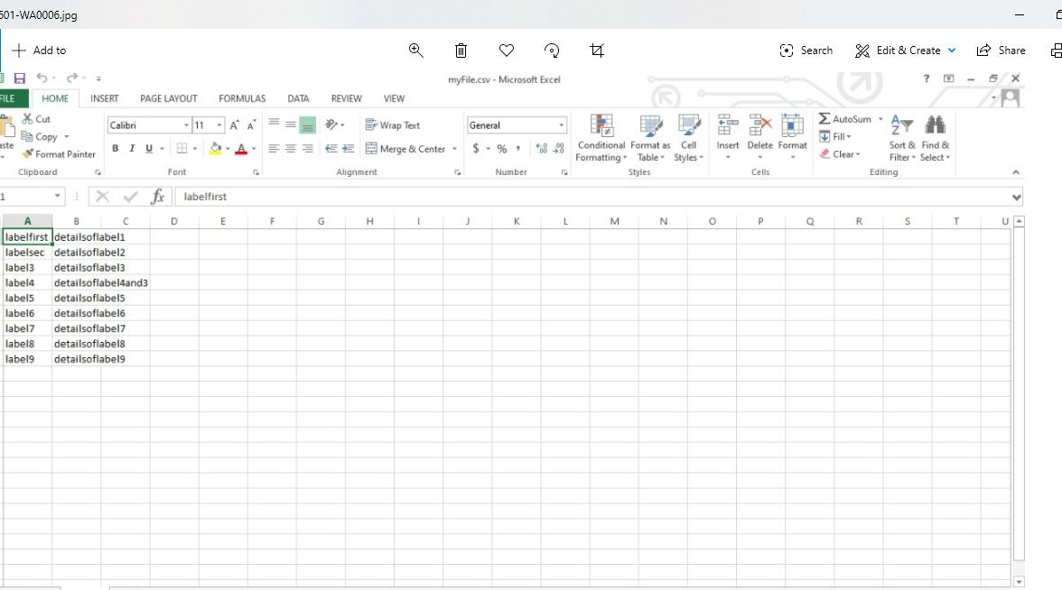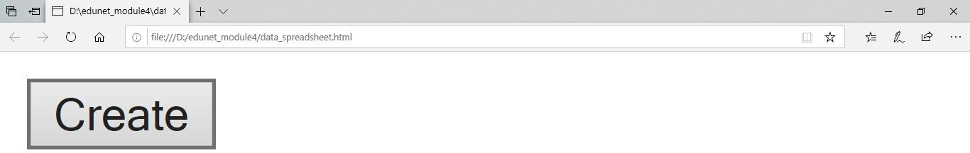

**References:**

* <https://www.codeproject.com/Questions/1116401/Insert-data-into-CSV-file-using-javascript>
* <https://stackoverflow.com/questions/22550858/how-to-write-csv-file-using-javascript>

# Activity 15

## Aim: Optimize HTML table rendering (1Hr)

**Learning outcome:** Able to Structuring the web.

**Duration:** 1 hour

**List of Hardware/Software requirements:**

1. Windows/Ubuntu OS
2. Text Editor- Sublime Text ,Notepad++
3. Browser

**Code/Program/Procedure (with comments):**

<!DOCTYPE html>

<html>

<head>

<style> table, th, td {

border: 1px solid black;

}

</style>

</head>

<body>

<table>

<tr>

<th>Month</th>

<th>Savings</th

<th>Savings for holiday!</th>

</tr>

<tr>

<td>January</td>

<td>$100</td>

<td rowspan="2">$50</td>

</tr>

<tr>

<td>February</td>

<td>$80</td>

</tr>

</table>

</body>

</html>

**Output/Results snippet:**

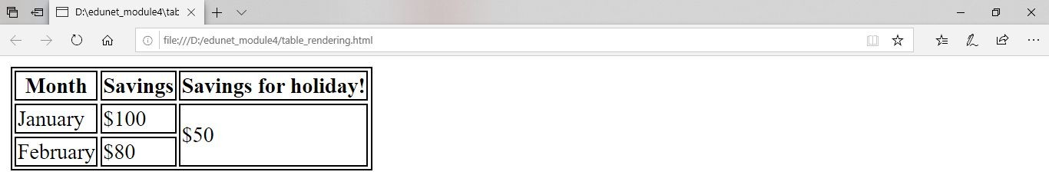

**References:**

● <https://stackoverflow.com/questions/21531269/optimizing-html-tables>

● <https://seymour.co.za/2017/07/03/html-table/>

# Activity 16

## Aim: Create collapsible content with HTML (1Hr)

**Learning outcome:** Able to Structuring the web.

**Duration:** 1 hour

**List of Hardware/Software requirements:**

1. Windows/Ubuntu OS
2. Text Editor- Sublime Text, Notepad++
3. Browser

**Code/Program/Procedure (with comments):**

<!DOCTYPE html>

<html>

<head>

<meta name="viewport" content="width=device-width, initial-scale=1">

<style>

.collapsible { background-color: #777; color: white;

cursor: pointer; padding: 18px; width: 100%;

border: none; text-align: left; outline: none; font-size: 15px;

}

.active, .collapsible:hover { background-color: #555;

}

.content { padding: 0 18px; display: none; overflow: hidden;

background-color: #f1f1f1;

}

</style>

</head>

<body>

<h2>Collapsibles</h2>

<p>A Collapsible:</p>

<button class="collapsible">Open Collapsible</button>

<div class="content">

<p>Data 1.</p>

</div>

<p>Collapsible Set:</p>

<button class="collapsible">Open Section 1</button>

<div class="content">

<p>Data 2.</p>

</div>

<button class="collapsible">Open Section 2</button>

<div class="content"

<p>Data 3.</p>

</div>

<button class="collapsible">Open Section 3</button>

<div class="content">

<p>Data 4.</p>

</div

<script>

var coll = document.getElementsByClassName("collapsible"); var i;

for (i = 0; i < coll.length; i++) { coll[i].addEventListener("click", function() { this.classList.toggle("active");

var content = this.nextElementSibling; if (content.style.display === "block") {

content.style.display = "none";

} else {

content.style.display = "block";

}

});

}

</script>

</body>

</html>

**Output/Results snippet:**

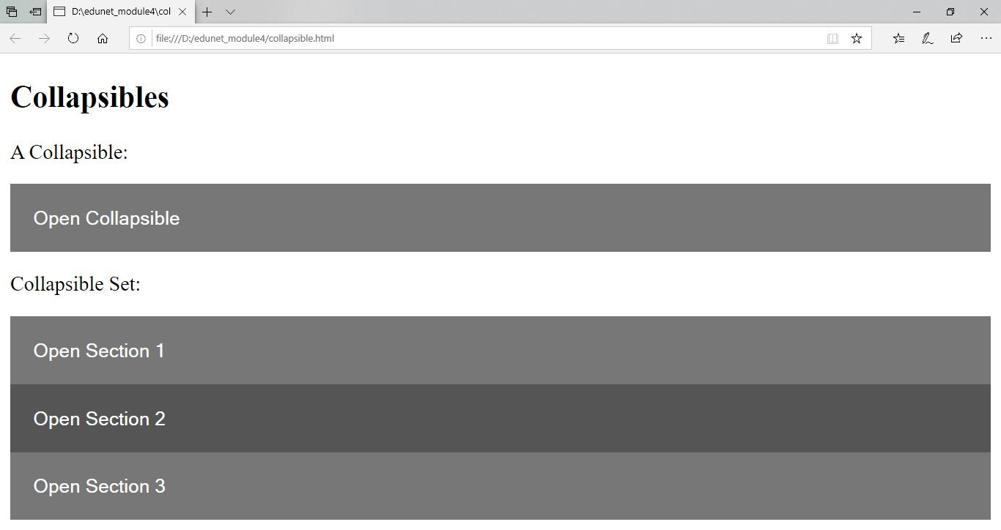

**References:**

● <https://www.w3schools.com/bootstrap/bootstrap_collapse.asp>

● <https://www.w3schools.com/howto/howto_js_collapsible.asp>

# Activity 17

## Aim: Add context menus to a webpage (2Hr)

**Learning outcome:** Able to Structuring the web.

**Duration:** 2 hour

**List of Hardware/Software requirements:**

1. Windows/Ubuntu OS
2. Text Editor- Sublime Text, Notepad++
3. Browser

**Code/Program/Procedure (with comments):**

<!DOCTYPE html>

<html>

<body>

<p>The <abbr title="World Health Organization">WHO</abbr> was founded in 1948.</p>

</body>

</html>

**Output/Results snippet:**

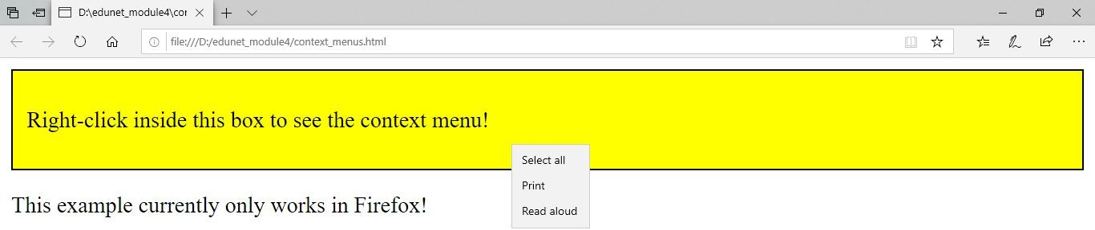

**References:**

* <https://stackoverflow.com/questions/4909167/how-to-add-a-custom-right-click-menu-to-a-webpage>
* <https://www.w3schools.com/jsref/event_oncontextmenu.asp>

# Activity 18

## Aim: Create dialog boxes with HTML (2Hrs)

**Learning outcome:** Able to Structuring the web.

**Duration:** 2 hour

**List of Hardware/Software requirements:**

1. Windows/Ubuntu OS
2. Text Editor- Sublime Text, Notepad++
3. Browser

**Code/Program/Procedure (with comments):**

<!DOCTYPE html>

<html>

<head>

<meta name="viewport" content="width=device-width, initial-scale=1">

<style>

body {font-family: Arial, Helvetica, sans-serif;}

/* The Modal (background) */

.modal {

display: none; /* Hidden by default */ position: fixed; /* Stay in place */

z- index: 1; /* Sit on top */

padding-top: 100px; /* Location of the box */ left: 0;

top: 0;

width: 100%; /* Full width */ height: 100%; /* Full height */

overflow: auto; /* Enable scroll if needed */ background-color: rgb(0,0,0); /* Fallback color */

background-color: rgba(0,0,0,0.4); /* Black w/ opacity */

}

/* Modal Content */

.modal-content { background-color: #fefefe; margin: auto;

padding: 20px;

border: 1px solid #888; width: 80%;

}

/* The Close Button */

.close {

color: #aaaaaa; float: right; font-size: 28px;

font-weight: bold;

}

.close:hover,

.close:focus { color: #000;

text-decoration: none; cursor: pointer;

}

</style

</head>

<body>

<h2>Modal Example</h2>

<!-- Trigger/Open The Modal -->

<button id="myBtn">Open Modal</button>

<!-- The Modal -->

<div id="myModal" class="modal">

<!-- Modal content -->

<div class="modal-content">

<span class="close">&times;</span>

<p>Some text in the Modal..</p>

</div>

</div>

<script>

// Get the modal

var modal = document.getElementById('myModal');

// Get the button that opens the moda

var btn = document.getElementById("myBtn");

// Get the <span> element that closes the modal

var span = document.getElementsByClassName("close")[0];

// When the user clicks the button, open the modal btn.onclick = function() {

modal.style.display = "block";

}

// When the user clicks on <span> (x), close the modal span.onclick = function() {

modal.style.display = "none";

}

// When the user clicks anywhere outside of the modal, close it window.onclick = function(event) {

if (event.target == modal) { modal.style.display = "none";

}

}

</script>

</body>

</html>

**Output/Results snippet:**

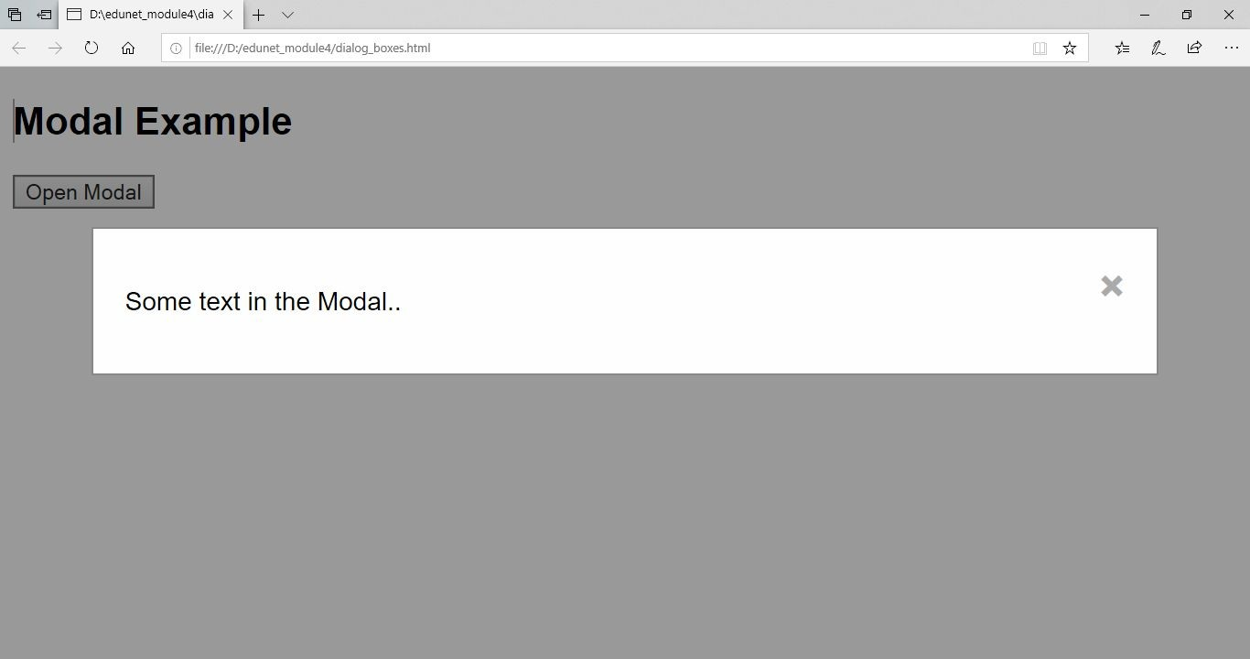

**References:**

● <https://www.javatpoint.com/html-dialog-tag>

● <https://www.w3schools.com/tags/tag_dialog.asp>

# Activity 19

## Aim: Add multiple languages into a single webpage (2Hrs)

**Learning outcome:** Able to Structuring the web.

**Duration:** 2 hour

**List of Hardware/Software requirements:**

1. Windows/Ubuntu OS
2. Text Editor- Sublime Text, Notepad+
3. Browser

**Code/Program/Procedure (with comments):**

<!doctype html>

<html lang="en">

<head>

<meta charset="utf-8">

<title>jQuery Language Switcher</title>

<link rel="stylesheet" href="languageswitcher.css">

</head>

<body>

<header>

<h1>jQuery Language Switcher</h1>

<div id="country-select">

<form action="server-side-script.php">

<select id="country-options" name="country-options">

<option selected="selected" title="http://www.yoursite.com" value="us">United States</option>

<option title="http://www.yoursite.co.uk" value="uk">United Kingdom</option>

<option title="http://www.yoursite.fr" value="fr">France</option>

<option title="http://www.yoursite.de" value="de">Germany</option>

<option title="http://www.yoursite.nl" value="nl">Netherlands</option>

</select>

<input value="Select" type="submit" />

</form>

</div>

</header>

<section>

<p>For more information, refer to the <a

href="/website-language-dropdown-withjquery">original article</a> on graphicpush.</p>

</section>

<script src="https://ajax.googleapis.com/ajax/libs/jquery/1.5.0/jquery.min.js"></script>

<script src="languageswitcher.js"></script>

</body>

</html>

languageswitcher.css

* { margin: 0; padding: 0; } body {

background: #ccc;

}

header { display: block;

background: #777; height: 50px; position: relative; min-width: 600px;

}

header h1 {

font: bold 24px Arial, Helvetica, sans-serif; color: #fff;

position: absolute; left: 20px;

top: 8px;

}

#country-select { position: absolute;

top: 13px; right: 0; width: 180px;

}

/* rought form styles for when JS is disabled */ #country-select form {

width: 180px; padding: 0;

}

#country-select select, #country-select input { display: inline; padding: 0;

margin: 0;

}

/* JS-created definition list */

.dropdown dd { position: relative; }

.dropdown a {

text-decoration: none; outline: 0;

font: 12px Arial, Helvetica, sans-serif; display: block;

width: 130px; overflow: hidden;

}

.dropdown dt a { background: #c45618; border: 1px solid #964315; padding: 3px 10px 4px 10px;

-webkit-border-radius: 5px;

-moz-border-radius: 5px; border-radius: 5px; color: #fff;

}

.dropdown dt a.active { background: #db5e18;

-webkit-border-bottom-left-radius: 0;

-webkit-border-bottom-right-radius: 0;

-moz-border-radius-bottomleft: 0;

-moz-border-radius-bottomright: 0;

border-bottom-left-radius: 0;

border-bottom-right-radius: 0; border-bottom: 1px dotted #676768;

-moz-box-shadow: 0 3px 7px rgba(0,0,0,.5);

-webkit-box-shadow: 0 3px 7px rgba(0,0,0,.5); box-shadow: 0 3px 7px rgba(0,0,0,.5);

color: #fff;

}

.dropdown dd ul { background: #814f33; border: 1px solid #676768; color: #C5C0B0;

display: none; position: absolute; z-index: 999;

top: 0;

left: 0;

padding: 2px 0 5px 0; list-style: none; border-top: none; margin: 0;

-webkit-border-bottom-right-radius: 5px;

-webkit-border-bottom-left-radius: 5px;

-moz-border-radius-bottomright: 5px;

-moz-border-radius-bottomleft: 5px; border-bottom-right-radius: 5px;

border-bottom-left-radius: 5px;

-moz-box-shadow: 0 3px 7px rgba(0,0,0,.5);

-webkit-box-shadow: 0 3px 7px rgba(0,0,0,.5); box-shadow: 0 3px 7px rgba(0,0,0,.5);

}

.dropdown dd ul li a { padding: 2px 10px;

}

.dropdown dd ul li a span,

.dropdown dt a span { float: left;

width: 16px; height: 11px;

margin: 2px 6px 0 0;

background-image: url(flags.png); background-repeat: no-repeat; cursor: pointer;

}

.us a span { background-position: 0 0 }

.uk a span { background-position: -16px 0 }

.fr a span { background-position: -32px 0 }

.de a span { background-position: -48px 0 }

.nl a span { background-position: -64px 0 }

.dropdown dd ul li a em,

.dropdown dt a em { font-style: normal; float: left;

width: 100px; cursor: pointer;

}

.dropdown dd ul li a em { color: #dbc3b5;

}

.dropdown dd ul li a:hover { background-color: rgba(255,255,255,.1); }

.dropdown dd ul li a:hover em { color: #fff; } Languageswitcher.js

$(document).ready(function() {

// --- language dropdown --- //

// turn select into dl createDropDown();

var $dropTrigger = $(".dropdown dt a"); var $languageList = $(".dropdown dd ul");

// open and close list when button is clicked

$dropTrigger.toggle(function() {

$languageList.slideDown(200);

$dropTrigger.addClass("active");

}, function() {

$languageList.slideUp(200);

$(this).removeAttr("class");

});

// close list when anywhere else on the screen is clicked

$(document).bind('click', function(e) { var $clicked = $(e.target);

if (! $clicked.parents().hasClass("dropdown"))

$languageList.slideUp(200);

$dropTrigger.removeAttr("class");

});

// when a language is clicked, make the selection and then hide the list

$(".dropdown dd ul li a").click(function() {

var clickedValue = $(this).parent().attr("class"); var clickedTitle = $(this).find("em").html();

$("#target dt").removeClass().addClass(clickedValue);

$("#target dt em").html(clickedTitle);

$languageList.hide();

$dropTrigger.removeAttr("class");

});

});

// actual function to transform select to definition list function createDropDown(){

var $form = $("div#country-select form");

$form.hide();

var source = $("#country-options"); source.removeAttr("autocomplete");

var selected = source.find("option:selected"); var options = $("option", source);

$("#country-select").append('<dl id="target" class="dropdown"></dl>')

$("#target").append('<dt class="' + selected.val() + '"><a href="#"><span class="flag"></span><em>' + selected.text() + '</em></a></dt>')

$("#target").append('<dd><ul></ul></dd>') options.each(function(){

$("#target dd ul").append('<li class="' + $(this).val() + '"><a href="' + $(this).attr("title") + '"><span class="flag"></span><em>' + $(this).text() + '</em></a></li>');

});

}

**Output/Results snippet:**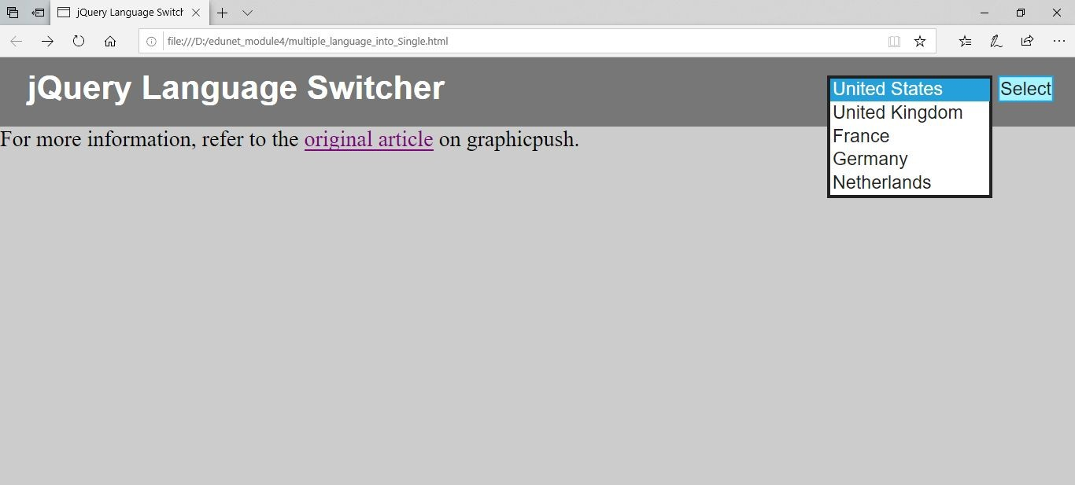

Image11: Add multiple languages into a single webpage

**References:**

* <https://stackoverflow.com/questions/46008760/how-to-build-multiple-language-website-using-pure-html-js-jquery>
* <https://forum.freecodecamp.org/t/what-is-the-best-way-to-create-a-multi-language-site/99449>

# Activity 20

## Aim: Controlling of HTML line breaking (1Hrs)

**Learning outcome:** Able to Structuring the web.

**Duration:** 1 hour

**List of Hardware/Software requirements:**

1. Windows/Ubuntu OS
2. Text Editor- Sublime Text, Notepad++
3. Browser

**Code/Program/Procedure (with comments):**

<p> O’er all the hilltops<br> Is quiet now,<br>

In all the treetops<br> Hearest thou<br> Hardly a breath;<br>

The birds are asleep in the trees:<br> Wait, soon like these<br>

Thou too shalt rest.

</p>

**Output/Results snippet:**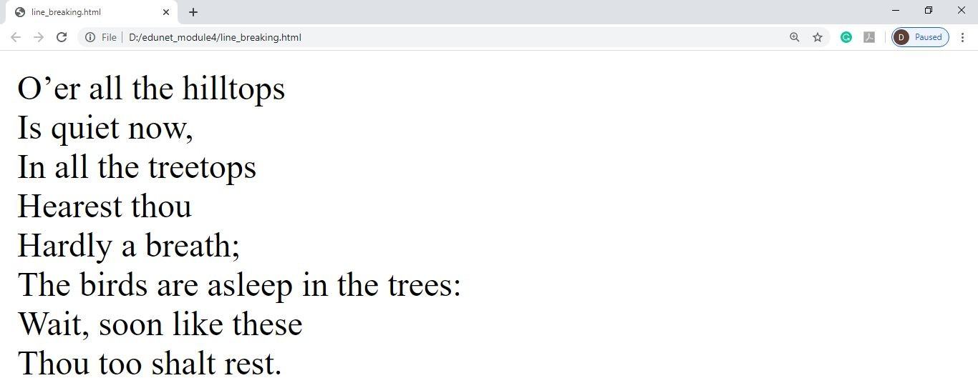

**References:**

* <https://www.informit.com/articles/article.aspx?p=131028&seqNum=7>
* <https://developer.mozilla.org/en-US/docs/Web/HTML/Element/br>

# Activity 21

## Aim: Mark changes (added and removed text) (2Hrs)

**Learning outcome:** Able to structure the web.

**Duration:** 2 hours

**List of Hardware/Software requirements:**

1. A computer with Windows/Linux/Mac operating system.
2. Any latest browser installed.
3. Any HTML editor (online/pre-installed).

**Code/Program/Procedure (with comments):**

<!DOCTYPE html>

<html

<body>

<h2>HTML <mark>Marked</mark> Formatting</h2

<p>The ins element represent inserted (added) text.</p>

<p>My favorite <ins>color</ins> is red.</p

<p>The del element represents deleted (removed) text.</p>

<p>My favorite color is <del>blue</del> red.</p>

</body>

</html>

**Output/Results snippet:**

HTML Marked Formatting

The ins element represent inserted (added) text.

My favorite color is red.

The del element represents deleted (removed) text.

My favorite color is blue red.

**References:**

* <https://www.w3schools.com/tags/tag_del.asp>

# Activity 22

## Aim: Add responsive image to a webpage (3Hrs)

**Learning outcome:** Able to structure the web.

**Duration:** 3 hours

**List of Hardware/Software requirements:**

1. A computer with Windows/Linux/Mac operating system.
2. Any latest browser installed.
3. Any HTML editor (online/pre-installed).

**Code/Program/Procedure (with comments):**

<!DOCTYPE html>

<html>

<head>

<meta name="viewport" content="width=device-width, initial-scale=1">

<style>

.responsive { /*creating a class in css and setting rules */ width: 100%;

max-width: 400px; height: auto;

}

</style>

</head>

<body>

<h2>Responsive Images</h2>

<p>If you want the image to scale both up and down on responsiveness, set the CSS width property to 100% and height to auto.</p>

<p>Resize the browser window to see the effect.</p>

<img src="flower.jpg" alt="Nature" class="responsive" width="600" height="400">

</body> <!-- import the image and apply the css class effects -- >

</html>

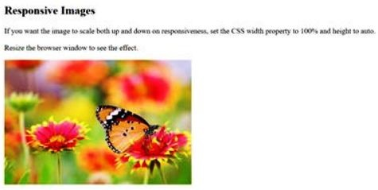**Output/Results snippet:**

**References:**

* <https://www.w3schools.com/howto/howto_css_image_responsive.asp>

# Activity 23

## Aim: Add vector image to a webpage (3Hrs)

**Learning outcome:** Able to structure the web.

**Duration:** 3 hours

**List of Hardware/Software requirements:**

1. A computer with Windows/Linux/Mac operating system.
2. Any latest browser installed.
3. Any HTML editor (online/pre-installed).

**Code/Program/Procedure (with comments):**

<html>

<body>

<svg width="100" height="100"> <!-- <svg> is a container for svg graphics -->

<circle cx="50" cy="50" r="40" stroke="green" stroke-width="4" fill="yellow" /> Sorry, your browser does not support inline SVG.

<!-- if circle is not displayed then this text will show -->

</svg>

</body>

</html>

 **Output/Results snippet:**

**References:**

* <https://www.w3schools.com/html/html5_svg.asp>

# Activity 24

## Aim: Add a hit map on top of an image (2Hrs)

**Learning outcome:** Able to structure the web.

**Duration:** 2 hours

**List of Hardware/Software requirements:**

1. A computer with Windows/Linux/Mac operating system.
2. Any latest browser installed.
3. Any HTML editor (online/pre-installed).

**Code/Program/Procedure (with comments):**

<!DOCTYPE html>

<html>

<body>

<p>Click on the sun or on one of the planets to watch it closer:</p>

<img src="planets.gif" width="145" height="126" alt="Planets" usemap="#planetmap">

<map name="planetmap">

<area shape="rect" coords="0,0,82,126" alt="Sun" href="sun.htm">

<area shape="circle" coords="90,58,3" alt="Mercury" href="mercur.htm">

<area shape="circle" coords="124,58,8" alt="Venus" href="venus.htm">

</map>

</body>

</html>

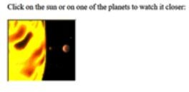**Output/Results snippet:**

**References:**

* <https://www.w3schools.com/tags/tag_map.asp>

# Activity 25

## Aim: Animation (1 hr)

**Duration:** 1 hours

**List of Hardware/Software requirements:**

1. A computer with Windows/Linux/Mac operating system.
2. Any latest browser installed.
3. Any HTML editor (online/pre-installed).

**Code/Program/Procedure (with comments):**

<!DOCTYPE html>

<html>

<head>

<style>

div {

width: 100px;

height: 100px;

background-color: red;

position: relative;

animation-name: example;

animation-duration: 4s;

}

@keyframes example {

0% {background-color:red; left:0px; top:0px;}

25% {background-color:yellow; left:200px; top:0px;}

50% {background-color:blue; left:200px; top:200px;}

75% {background-color:green; left:0px; top:200px;}

100% {background-color:red; left:0px; top:0px;}

}

</style>

</head>

<body>

<h1>CSS Animation</h1>

<div></div>

<p><b>Note:</b> When an animation is finished, it goes back to its original style.</p>

</body>

</html>

**Output/Results snippet:**

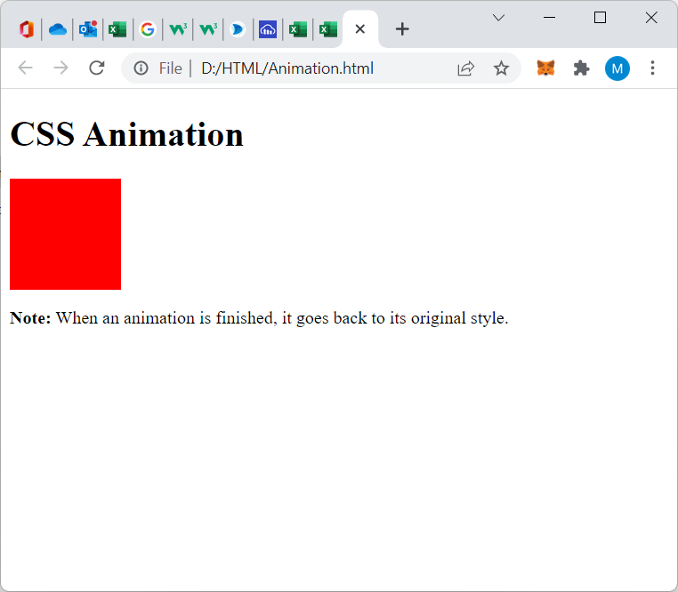

**Reference:**

* <https://www.w3schools.com/css/tryit.asp?filename=trycss3_animation3>

# Activity 26

## Aim: Transition (1 hr)

**Duration:** 1 hours

**List of Hardware/Software requirements:**

1. A computer with Windows/Linux/Mac operating system.
2. Any latest browser installed.
3. Any HTML editor (online/pre-installed).

**Code/Program/Procedure (with comments):**

<!DOCTYPE html>

<html>

<head>

<style>

div {

width: 100px;

height: 100px;

background: red;

transition: width 2s;

}

div:hover {

width: 300px;

}

</style>

</head>

<body>

<h1>The transition Property</h1>

<p>Hover over the div element below, to see the transition effect:</p>

<div></div>

</body>

</html>

**Output/Results snippet:**

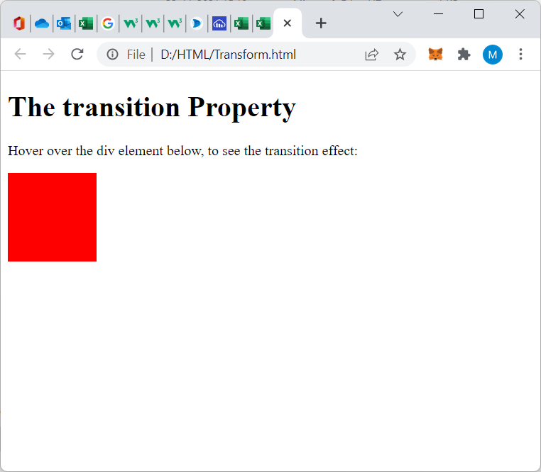

**Reference:**

* <https://www.w3schools.com/css/tryit.asp?filename=trycss3_transition2>